Did you know that Holmdel is famous amongst scientists as the place where the Horn Antenna resides? In 1964, Bell Labs researchers Robert Wilson and Arno Penzias
were using this massive, 20 ft. tall microwave antenna when they discovered cosmic microwave background radiation from beyond the Milky Way. This confirmed the Big Bang Theory of the creation of the universe. Both scientists won the Nobel Prize in Physics in 1978 for this discovery.
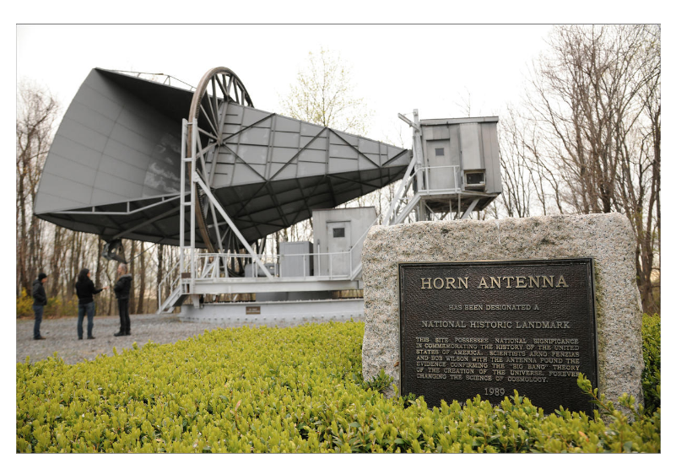
The antenna, which sits atop Crawford Hill along Holmdel Road, was designated a National Historic Landmark in 1989. Crawford Hill is the highest elevation in Monmouth County. The 43-acre property could be an excellent public park and historic site with walking/hiking trails, beautiful views of Raritan Bay and Manhattan, as well as the intact antenna on display.
Credit: American Museum of Natural History/R. Mickens

At a recent meeting, the Holmdel Township Committee passed a resolution prior to an application being submitted, asking the Planning Board whether the Crawford Hill Horn Antenna site should be designated an area in need of redevelopment. This raises the question of whether the town is considering development of the site which could lead to removal or destruction of the irreplaceable historical horn.

CILU is partnering with Preserve Holmdel to protect the Horn Antenna, but we need your help. If you care about the preservation of this Holmdel jewel, whose legacy goes far beyond our town’s borders, contact the Mayor and Township Committee, asking them to protect both the historic antenna and the grounds on which it sits. Their contact information is:
- Mayor Greg Buontempo mayor@holmdeltownship.com
- Committeeman DJ Lucarelli dluccarelli@holmdeltownship.com
- Committeeman Rocco Impreveduto rimpreveduto@holmdeltownship.com
- Committeeman Brian Foster bfoster@holmdeltownship.com
Stay tuned for more information and action on this issue.
Regina Criscione & Karen Strickland, Copresidents, Citizens for Informed Land Use (CILU)
Gerald Buffalino, President, Preserve Holmdel (PH)

